
MANGALORE INSTITUTE OF TECHNOLOGY & ENGINEERING
(A Unit of Rajalaxmi Education Trust®, Mangalore)
Autonomous Institute affiliated to VTU, Belagavi, Approved by AICTE, New Delhi
Accredited by NAAC with A+ Grade & ISO 9001:2015 Certified Institution

DISASTER PREDICTION SYSTEM

MINI-PROJECT
(23MCSE527)

REPORT

Submitted by

Pramod Adappa Sankannavar

4MT24MC067

In partial fulfilment for the award of the degree of

MASTER OF COMPUTER APPLICATIONS

2024-25

MANGALORE INSTITUTE OF TECHNOLOGY & ENGINEERING
(A Unit of Rajalaxmi Education Trust®, Mangalore)
Autonomous Institute affiliated to VTU, Belagavi, Approved by AICTE, New Delhi
Accredited by NAAC with A+ Grade & ISO 9001:2015 Certified Institution

DEPARTMENT OF MASTER OF COMPUTER APPLICATIONS

CERTIFICATE

This is to certify that Pramod Adappa Sankannavar, bearing USN (4MT24MC067) has successfully completed the second semester Mini-Project entitled Disaster Prediction System as a partial fulfilment of the requirements for the award of MASTER OF COMPUTER APPLICATIONS degree, during the Academic Year 2024-25.

Signature of the Guide Head of the Department

Internal Examiner External Examiner

Name & Signature Name & Signature
DECLARATION
I, Pramod Adappa Sankannavar, student of II Semester MCA, bearing 4MT23MC067 hereby declare that the project work entitled “DISASTER PREDICTION SYSTEM” has been carried out under the supervision of Dr. Anushree Raj, Assistant Professor, MCA and submitted as the partial fulfilment of the requirements for the award of the Degree of Master of Computer of Applications, Mangalore Institute of Technology & Engineering, an Autonomous Institution, Affiliated to Visvesvaraya Technological University during the academic year 2024-25. This report has not been submitted to any other Organization/University for any award of degree.

Name:
Signature:

Date:
ACKNOWLEDGEMENT

I would like to thank Mr. Rajesh Chouta, Chairman, Mangalore Institute of Technology & Engineering for providing a good infrastructure for timely completion of my mini-project.
I sincerely express my gratitude to Dr. Prashanth C M, Principal, MITE, for supporting me in all my technical activities and giving proper guidance when it was required. I would like to thank Dr. Madhwaraj K G, Professor & HD, Department of MCA, for granting permission to undertake this project. I would like to express my gratitude to my project guide Dr. Anushree Raj, Assistant Professor, MCA for giving all the instructions and guidelines at every stage of the Project work.
I thank all the staff members of the Department of Master of Computer Applications, for extending their constant support to complete this project. I express my heartfelt thanks to my parents and friends who were also a constant source of support and inspiration throughout this project.

TABLE OF CONTENTS

Chapter No | Title | Page No
 | ABSTRACT | 1
1 | INTRODUCTION | 2-5
1.1 | Introduction | 2-5
1.2 | Problem Statement | 2-5
1.3 | Objectives of the project | 2-5
1.4 | Existing System | 2-5
1.5 | Proposed System | 2-5
1.6 | Feasibility Study | 2-5
2 | REVIEW OF LITERATURE | 6-7
3 | SYSTEM CONFIGURATION | 8-9
3.1 | Hardware requirements | 8-9
3.2 | Software requirements | 8-9
4 | MODULE DESCRIPTION | 10-11
4.1 | Modules | 10-11
5 | SYSTEM DESIGN | 12-14
5.1 | Data Flow Diagrams | 12-14
5.2 | Use Case Diagram | 12-14
6 | SYSTEM IMPLEMENTATION | 15-17
6.1 | Implementation | 15-17
6.2 | Screenshots | 15-17
7 | SYSTEM TESTING | 18-19
7.1 | Test cases
8 | RESULTS AND DISCUSSION
8.1 | Conclusions | 20-21
8.2 | Future Enhancements
9 | REFERENCES
9.1 | Text references | 22
9.2 | Web references

LIST OF FIGURES

Sl.  No. | Figure No | Title | Page No.
1 | Fig 5.1.1 | DFD LEVEL – 0 | 12
2 | Fig 5.1.2 | DFD LEVEL – 1 | 13
3 | Fig 5.2.1 | USE CASE DIAGRAM | 14
4 | Fig 6.2.1 | Home Screen | 16
5 | Figure 6.2.2 | Weather Data Display | 17

ABSTRACT

Disaster Prediction System

This project presents the design and implementation of a "Disaster Prediction System," a desktop application developed to assess and alert users about potential natural disaster risks. The current version of the system is specifically focused on seismic activity, providing earthquake risk prediction. Built using Python and the Tkinter library for the graphical user interface (GUI), the system leverages real-time data fetched from the United States Geological Survey (USGS) API.

Users can input specific geographic coordinates to receive an immediate risk assessment. The application calculates the proximity and magnitude of the nearest recent seismic events to determine a risk level, which is then communicated to the user through distinct visual cues and audio alerts, enhancing the urgency and clarity of the information. Furthermore, the system maintains a secure and personalized record of all user predictions by storing them in a MySQL database, allowing users to review their query history.

This report comprehensively details the system's development lifecycle, including its objectives, system design, module descriptions, implementation specifics, and rigorous testing procedures. The final product successfully fulfills all the functional requirements outlined in the Software Requirements Specification (SRS), resulting in a functional, user-friendly tool for proactive disaster awareness.

CHAPTER
1. INTRODUCTION
1.1 Introduction
Natural disasters are catastrophic events with atmospheric, geological, and hydrological origins that cause significant damage, disruption, and loss of life. Earthquakes, being sudden and unpredictable, are among the most devastating. The “Disaster Prediction System” is a proactive technological solution designed to mitigate these adverse effects. This project moves beyond mere data display; it synthesizes real-time geospatial data from authoritative sources with user input to generate personalized risk assessments. By providing immediate, understandable feedback through an intuitive interface, it empowers individuals and communities with crucial information that can inform safety decisions and preparedness actions, ultimately contributing to disaster risk reduction.

1.2 Problem Statement
Current disaster prediction systems are often inaccessible to the general public. They are typically either highly complex scientific models used by seismologists, requiring expert knowledge, or oversimplified public alerts that offer no interactive assessment. This creates a gap where citizens lack a user-friendly tool to proactively assess their personal risk based on their specific location and real-time data. This project aims to bridge that gap by developing an accessible desktop application that provides immediate, personalized earthquake risk predictions.

1.3 Objectives of the project
The primary objectives of the Disaster Prediction System are to:
- Develop a secure user authentication system with registration and login functionalities to personalize the user experience.
- Integrate with the United States Geological Survey (USGS) API to fetch real-time, reliable earthquake data.
- Create an intuitive and user-friendly graphical user interface (GUI) for easy navigation, input of coordinates, and clear viewing of results.
- Implement a core algorithm to process the data, calculate the distance to the nearest seismic event, and assess the risk level based on magnitude and proximity.
- Provide distinct visual and audio cues based on the calculated risk level to ensure the message is conveyed effectively and urgently.
- Maintain a persistent and private history of all user predictions in a MySQL database for later review and analysis.

1.4 Existing System
The existing landscape for public-facing earthquake information consists primarily of:
1.Scientific Portals (e.g., USGS website): Provide raw and complex data, maps, and technical metrics that are invaluable for experts but overwhelming for the average user.
2.General News Alerts: Offer post-event information about major earthquakes but lack predictive capabilities or personalized risk assessment.
3.Mobile Alert Systems (e.g. Shake Alert): Provide crucial seconds of warning but are typically region-locked, limited to major events, and do not allow for on-demand risk queries for any location.
These systems lack a simple, on-demand tool for a user to check the seismic risk for their specific area of interest using the latest data.

1.5 Proposed System
The proposed “Disaster Prediction System” is a standalone desktop application that addresses the shortcomings of existing systems. It features a secure login/registration system, a central dashboard for navigation, and dedicated modules for earthquake prediction and history review. Its core function is to take user-provided latitude and longitude, fetch the latest earthquake data from the USGS API, calculate the nearest event and its parameters, and instantly display a clear risk level (e.g., Low, Medium, High, Extreme) with corresponding visual and audio feedback. All interactions are stored locally in a database, providing users with a personalized log of their queries.

1.6 Feasibility Study
- Technical Feasibility: The project is built on a stack of mature and robust technologies (Python, Tkinter, MySQL, Pandas, Requests, Geopy, Pygame). The USGS API is reliable and well-documented. This makes the project technically sound and achievable.
- Economic Feasibility: The development cost is minimal as the entire project utilizes Free and Open-Source Software (FOSS). There are no licensing fees, and the hardware requirements are modest.
- Operational Feasibility: The system is designed for ease of use. The GUI is intuitive, requiring users only to input coordinates. This low barrier to entry ensures it can be operated by students, researchers, and citizens without specialized training.

2. REVIEW OF LITERATURE

The development of this system is informed by research in several key areas:
- Seismic Data Analysis: Studies on the correlation between earthquake magnitude, proximity to the epicenter, and potential impact formed the basis for the risk assessment algorithm. The use of the Haversine formula for calculating great-circle distances is a standard in geospatial analysis.
- API Integration & Web Services: The project leverages standard practices for consuming RESTful APIs, handling HTTP requests and responses (using the `requests` library), and parsing JSON data, which is fundamental to modern software development.
- Human-Computer Interaction (HCI): The interface design prioritizes usability principles. The use of immediate multi-sensory feedback (visual and audio) is a recognized method for ensuring critical information is noticed and understood quickly.
- Database Management: The use of a relational database management system (MySQL) follows best practices for data persistence, ensuring data integrity, efficient storage, and retrieval of user and historical data.
This project differentiates itself by integrating these established concepts into a single, user-focused application that simplifies complex data into an actionable risk assessment.

3. SYSTEM CONFIGURATION
3.1 Hardware Requirements
- Processor: Intel Core i3 or equivalent AMD processor.
- RAM: 4 GB (8 GB recommended for smoother operation).
- Storage: Minimum 500 MB of free disk space for the application, database, and associated files.
- Display: 1024x768 resolution or higher.
- Network: A stable broadband internet connection for fetching real-time data from the USGS API.

3.2 Software Requirements
- Operating System: Windows 10 or Windows 11.
- Programming Language: Python 3.8 or higher.
- Database Server: MySQL Community Server 8.0 or higher.
- Python Libraries:
- tkinter (GUI, built-in)
- pymysql or mysql-connector-python` (MySQL database connectivity)
- requests (HTTP requests to USGS API)
- pandas (Data manipulation and analysis)
- geopy (Calculating geographical distances)
- Pillow (PIL) (Image processing for GUI graphics)
- pygame (Playing audio feedback for risk alerts)

4. MODULE DESCRIPTION
4.1 Modules
The system is architecturally divided into the following cohesive modules:
1. User Authentication Module: Manages the entire user lifecycle, including new user registration (storing credentials in the ‘users_details’ table) and existing user login (validating against stored credentials). It establishes and maintains user sessions.
2.Data Retrieval Module: Responsible for all external communication. It constructs the HTTP request URL with parameters, calls the USGS API's `query` endpoint, handles errors (e.g., no internet), and parses the returned JSON data into a structured format for the system to use.
3.Prediction & Analysis Engine: The computational core. It takes the user's coordinates and the fetched seismic data. It uses the `geopy` library to calculate distances to each event, identifies the nearest earthquake, and applies a risk algorithm (based on magnitude and distance thresholds) to classify the risk level.
4.User Interface (GUI) Module: Built with Tkinter, this module creates all windows (login, dashboard, prediction, history). It handles all user input events (clicks, text entry) and displays all outputs (text, images, buttons) in a structured layout.
5.History Management Module: Handles all database operations related to user history. After a prediction is made, it saves the parameters (coordinates, result, timestamp) to the `eq_history` table. It also retrieves and displays this history upon user request.
6.Feedback Module: This module provides multi-sensory output. Based on the risk level determined by the analysis engine, it dynamically loads corresponding background images (e.g., red for danger) and triggers the playback of associated sound files using pygame.mixer.

5. SYSTEM DESIGN**
5.1 Data Flow Diagrams (DFD)
The Level 1 DFD illustrates the flow of data through the system's main processes:
1. **Process "Authenticate User":** The user inputs credentials. The process sends a query to the **User Data** store. Valid credentials allow the flow to proceed to the main application, while invalid credentials generate an error message.
2. **Process "Fetch Seismic Data":** The system automatically sends a request to the **USGS API** external entity. The API returns a flow of **Seismic Data**.
3. **Process "Calculate Risk":** This process takes the **User Coordinates** and the **Seismic Data**. It performs calculations and outputs a **Risk Result**.
4. **Process "Display & Log Result":** The **Risk Result** is sent to the user interface. Simultaneously, the result, along with user details, is stored as a **History Record** in the **Prediction History** data store.
5. **Process "Show History":** Upon user request, this process retrieves **History Records** for the logged-in user from the data store and displays them.

5.2 Use Case Diagram
The system has two primary actors:
* **New User:** Can perform the `Register` use case to create a new account.
* **Registered User:** Can perform several use cases:
* `Login` to the system.
* `Predict Earthquake Risk` (which includes the system `Fetch Data from USGS API`).
* `View Prediction History` (which involves the system `Retrieve Data from Database`).

The system itself interacts with two external entities/systems to complete these tasks: the **USGS API** and the **MySQL Database**.

---

6. SYSTEM IMPLEMENTATION

6.1 Implementation
The system was implemented in Python using an object-oriented approach where possible. Key classes include:
- Login_class: Handles the GUI and logic for the login window.
- Registration_class : Manages the user registration process and database insertion.
- earthquake_analysis_class: The main class containing the core logic for fetching USGS data, calculating distances, determining risk, and managing the prediction GUI.
Database connectivity is achieved using the `pymysql` library to execute SQL queries (INSERT for registration/history, SELECT for login/history retrieval). The `geopy.distance.distance` function is used for accurate geographical distance calculations. The `pygame.mixer` module is initialized to load and play `.mp3` files for audio alerts.

6.2 Screenshots
Register Form:
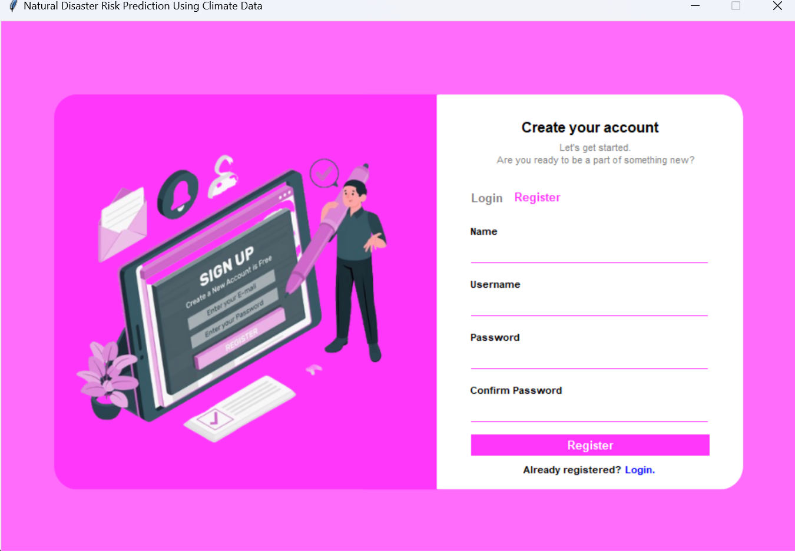

Login Form:
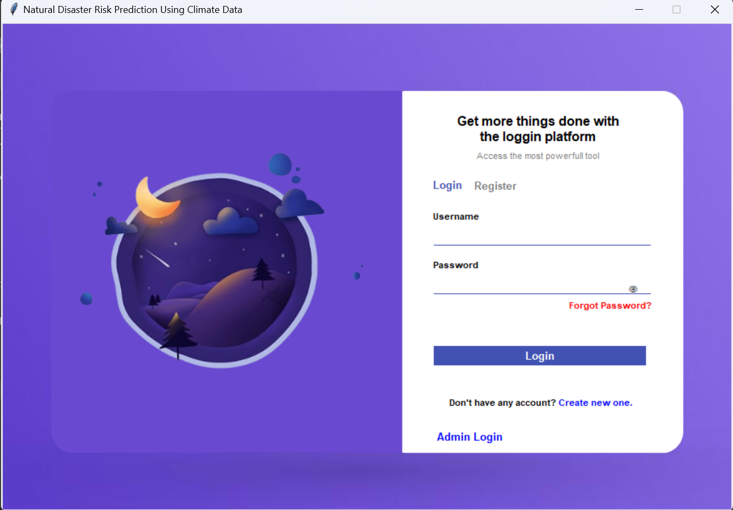

Dashboard:
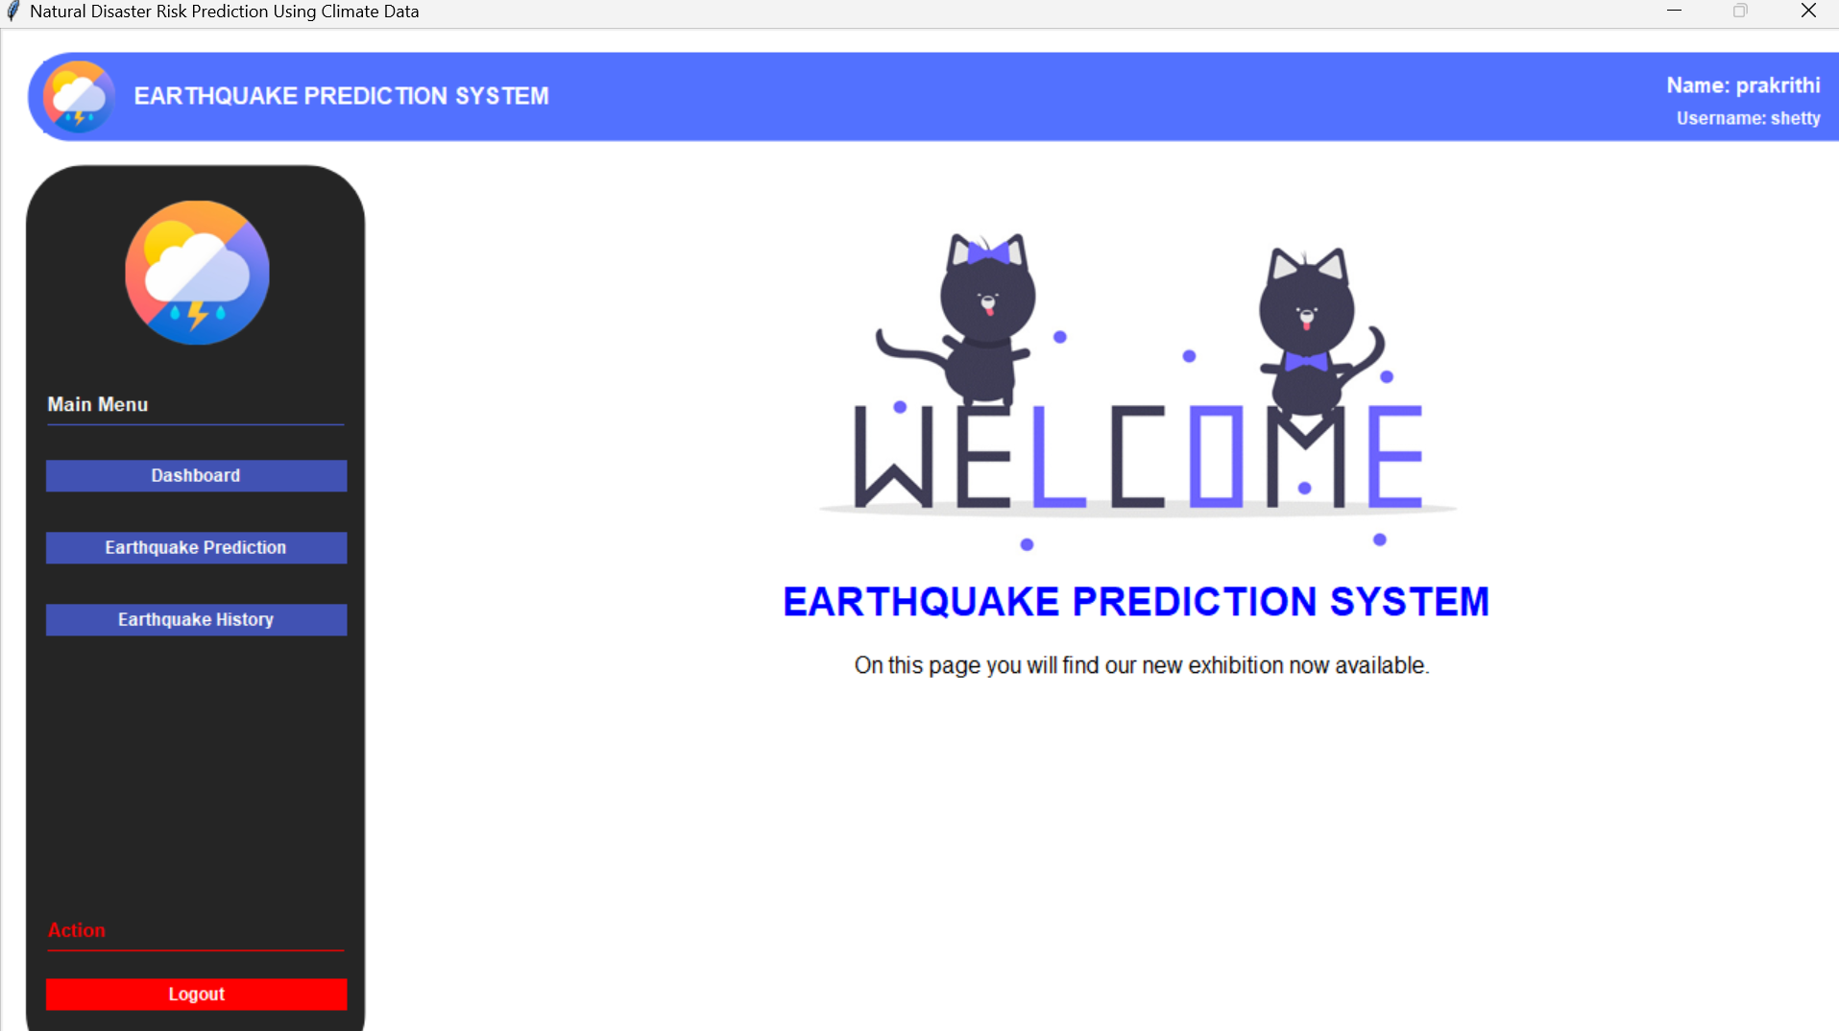

7. SYSTEM TESTING
7.1 Test Cases:
Test Case No. | Test Scenario | Input Data | Expected Result | Status
TC-01 | Successful User Login | Valid Username, Valid Password | Access granted to user dashboard. | Pass
TC-02 | Failed User Login | Invalid Username, Any Password | Error: "Invalid credentials". Access denied. | Pass
TC-03 | Successful Admin Login | Valid Admin ID, Valid Admin Password | Access granted to admin portal/system console. | Pass
TC-04 | Failed Admin Login | Invalid Admin ID, Any Password | Error: "Invalid admin credentials". Access denied. | Pass
TC-05 | Successful Risk Prediction with Valid Coordinates | Latitude: 12.9716, Longitude: 77.5946 | System fetches data and displays a risk level (e.g., Low, Medium, High). | Pass
TC-06 | Prediction with Invalid Data Type | Latitude: "abc", Longitude: 77.5946 | Error: "Please enter valid numerical coordinates." | Pass
TC-07 | Prediction with Out-of-Bound Coordinates | Latitude: -91.0, Longitude: 200.0 | Error: "Coordinates are out of valid range." | Pass
TC-08 | Fetch Real-time Seismic Data | (Automatic upon valid prediction) | System successfully retrieves and parses latest data from USGS API. | Pass
TC-09 | Save Prediction to Database | (Automatic after TC-05) | Prediction result and metadata are stored in the database. | Pass
TC-10 | View Prediction History | User navigates to history page. | System displays a list of all past predictions made by the logged-in user. | Pass

8. RESULTS AND DISCUSSION

8.1 Conclusion
The Disaster Prediction System project was successfully implemented and met all its stated objectives. A secure user authentication system was developed, real-time data was seamlessly integrated from the USGS API, and an intuitive Tkinter-based GUI was created. The core functionality of calculating earthquake risk based on user-provided coordinates works accurately, providing clear visual and audio feedback. The system effectively stores and retrieves prediction history from a MySQL database. The project demonstrates a practical and valuable application of software engineering principles to the domain of disaster awareness and risk mitigation.
8.2 Future Enhancements
    - Multi-Hazard Prediction: Expand the system to predict floods, cyclones, and wildfires by integrating additional APIs (e.g., GloFAS, IMD).
    - Enhanced Security: Implement password hashing (e.g., bcrypt) instead of storing plain text passwords in the database.
    - Interactive Map: Integrate an interactive map (e.g., using TkinterMapView or Folium) for users to click and select locations instead of manually typing coordinates.
    - Push Notifications: Develop a background service to monitor data and send SMS/email alerts for high-risk events near a user's saved locations.
    - Data Visualization: Add charts and graphs to the history section to visualize risk trends over time for a specific location.
    - Cross-Platform Support: Refactor the GUI using a more portable library like PyQt or Kivy to support macOS and Linux.

9. REFERENCES
9.1 Text References
1. Matthes, E. (2019). Python Crash Course, 2nd Edition: A Hands-On, Project-Based Introduction to Programming. No Starch Press.
2. M. J. (2018). MySQL for Beginners. CreateSpace Independent Publishing Platform.
9.2 Web References
- USGS Earthquake CatLog API Documentation:
https://earthquake.usgs.gov/fdsnws/event/1/
- Python Tkinter Documentation: https://docs.python.org/3/library/tkinter.html
- Geopy Documentation: https://geopy.readthedocs.io/en/stable/
- Pygame Documentation: https://www.pygame.org/docs/
- PyMySQL Documentation: https://pymysql.readthedocs.io/

